**Design Specification**

Version: 0.2

November 8, 2018

Document ID: 00001

Author:

|  |  |
| --- | --- |
| Student Number | Name |
| 20165187 | Geping Chen |
| 20165164 | Peiyi Yang |
| 20165140 | Jianxiang Wang |

**Table of Contents**

Version History ii

1.0 Introduction 1

2.0 System Architecture 2

2.0.1 Deployment Diagram 2

2.0.2 Component Diagram 3

3.0 Packages 4

4.0 Class Diagrams 5

4.1 Cloud Service 5

4.2 Codec 5

4.3 Communication 6

4.4 Communication System 6

4.5 Monitor 7

4.6 Radar System 7

4.7 Schedule 8

4.8 Tower Control 8

5.0 Interaction Diagrams 9

5.1 Sequence Diagram 9

5.1.1 Broadcast Sequence Diagram 9

5.1.2 Monitor Safe Distance Diagram 9

5.1.3 Remove Canceled Aircraft Sequence Diagram 10

5.2 Communication Diagram 10

5.2.1 Change Priority Of Landing Queue 10

5.2.2 Monitor Boarder 11

5.2.3 Send One-to-One Instructions 11

6.0 State Machine Diagrams 12

6.1 Aircraft 12

6.2 Flight 12

6.3 Message 13

7.0 Summary 14

References 15

# Version History

|  |  |  |
| --- | --- | --- |
| **Issue** | **Date** | **Change** |
| 0.1 | 7/11/2018 | Initial version |
| 0.2 | 8/11/2018 | Added deployment and component diagrams. |

# Introduction

This documentation shows the design of the Air Traffic Control System. The software has three main functions: monitoring aircraft status, scheduling for departure and landing, and communication between ATCs and pilots.

This design followes the MVC pattern, and GUI design is not provided. The system should be deployed on a computer instead of a mobile phone and connect to the server.

# System Architecture

## 2.0.1 Deployment Diagram

We use MVC architecture in our design. The software is deployed on a computer and is connected to a database server. In the application layer, the software uses services from the radar system, communication system and the cloud service, and uses a codec interface for decoing and encoding messages.

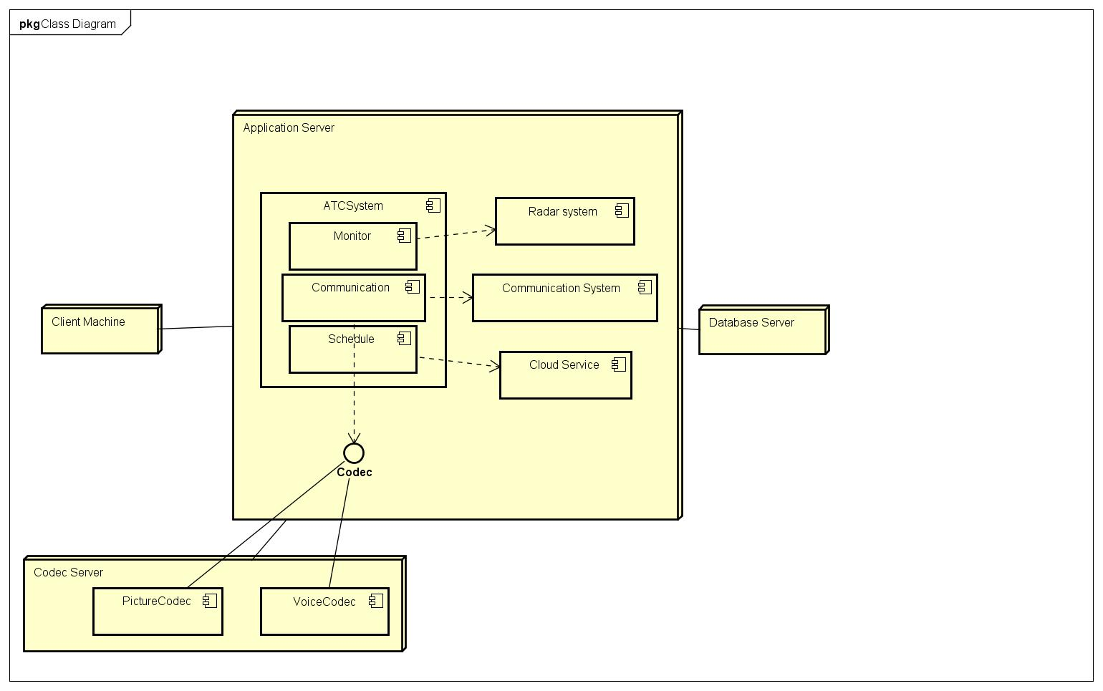

## 2.0.2 Component Diagram

The ATC system consists of 3 components: Monitor, which uses the radar system to get the location of aircrafts and monitor the safety status of aircrafts; Communication, which uses the communication system to send and receive information, and uses the codec to encode and decode messages; Schedule, which uses the cloud services to allow specialist ATCs to manage the sequence of landing and departure queues.

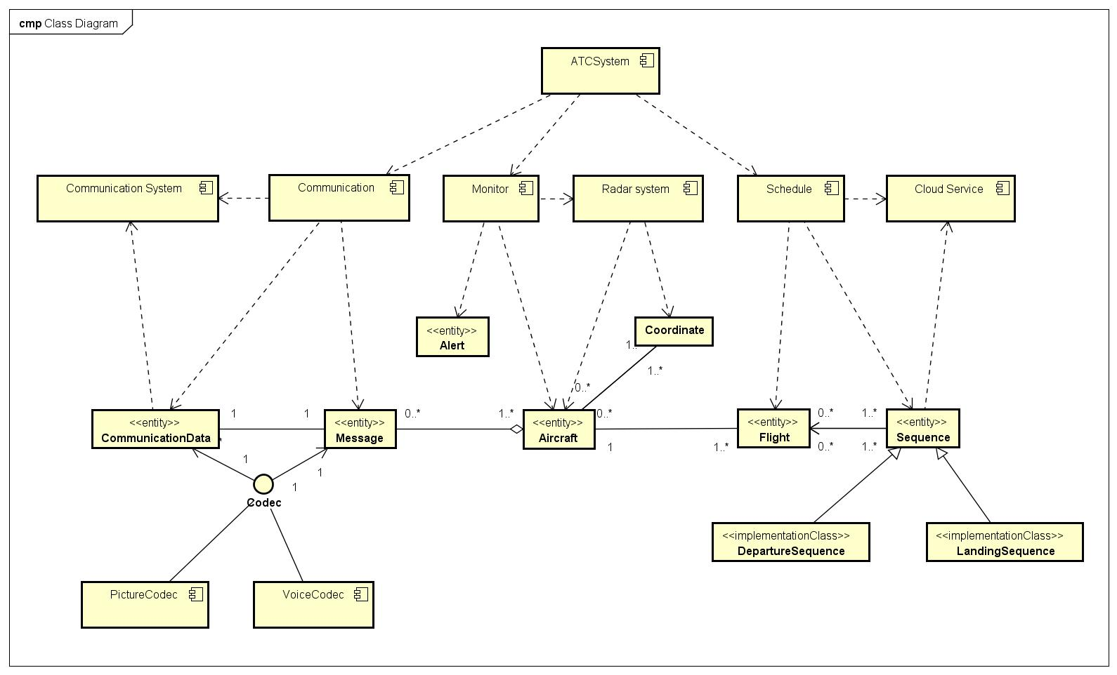

# Packages

|  |  |
| --- | --- |
| **Package Name** | **Description** |
| Cloud Service | Provides access to a cloud-based database that stores the sequence of landing and departure aircrafts. |
| Codec | An interface for encoding and decoding messages in the communication system. |
| Communication | Implemetation of sending instructions and receiving feedback. |
| Communication System | Provides access to the data from communication devices. |
| Monitor | Implemetation of monitoring safe diatance between aircrafts and boarder status. |
| Radar System | Provides access to the data from radar devices. |
| Schedule | Implemetation of managing the sequence of landing and departure aircrafts. |
| Tower Control | This package contains the basic modelling classes of the system, such as ATC and Airport. |

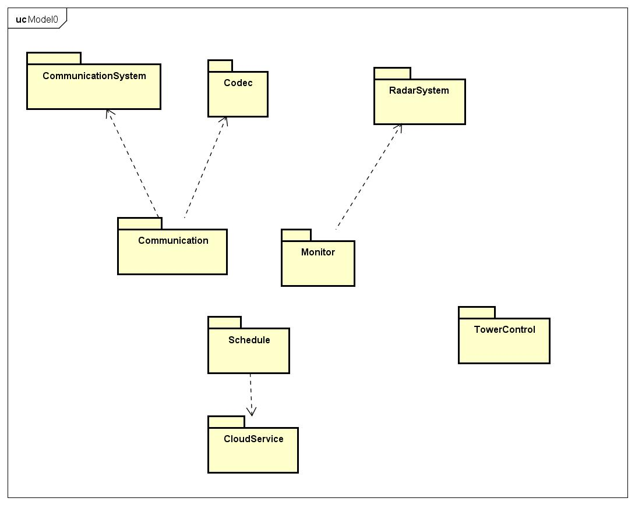

# Class Diagrams

## 4.1 Cloud Service

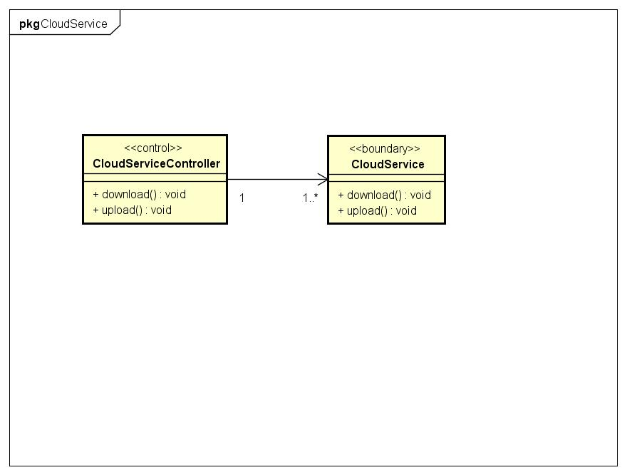

## 4.2 Codec

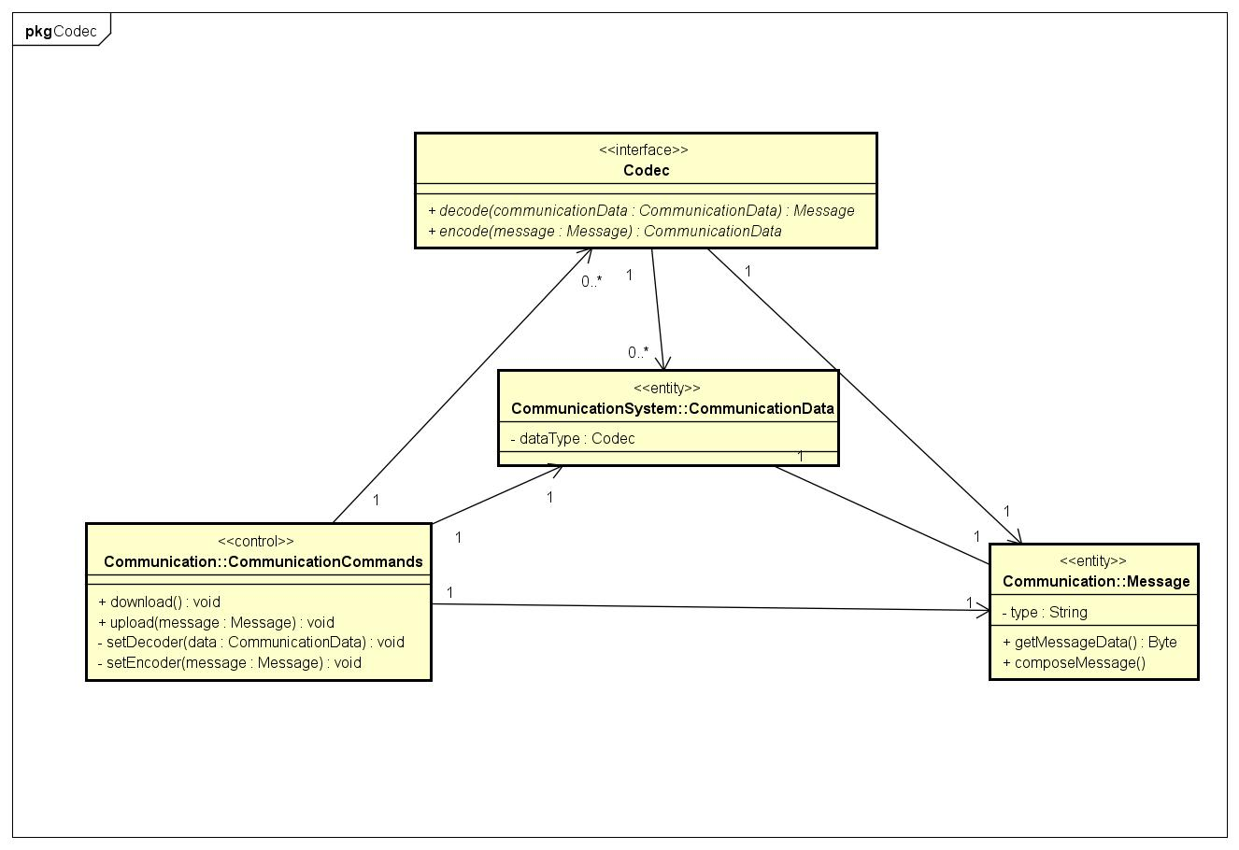

## 4.3 Communication

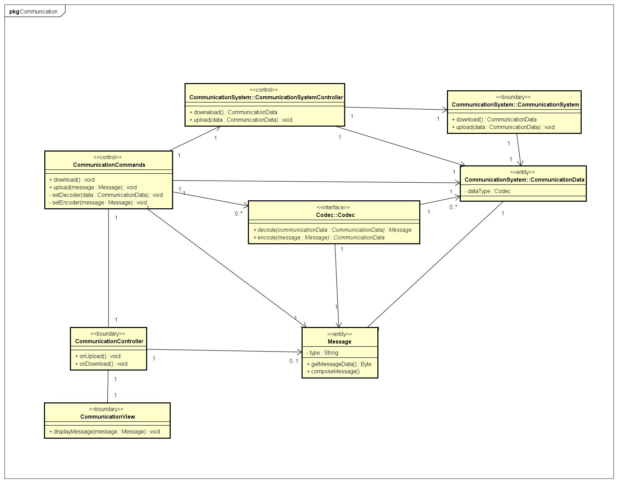

## 4.4 Communication System

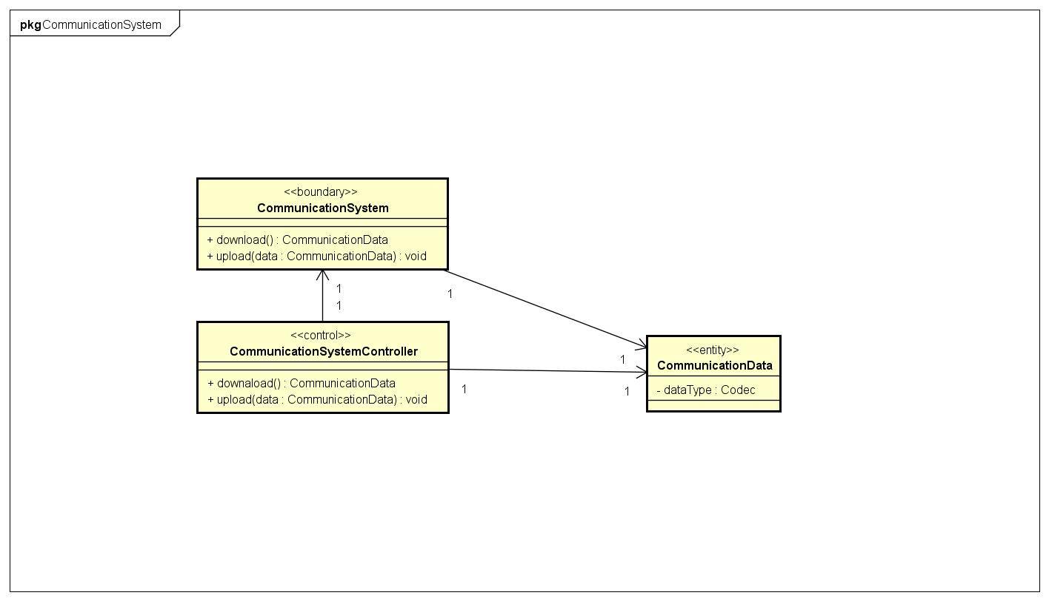

## 4.5 Monitor

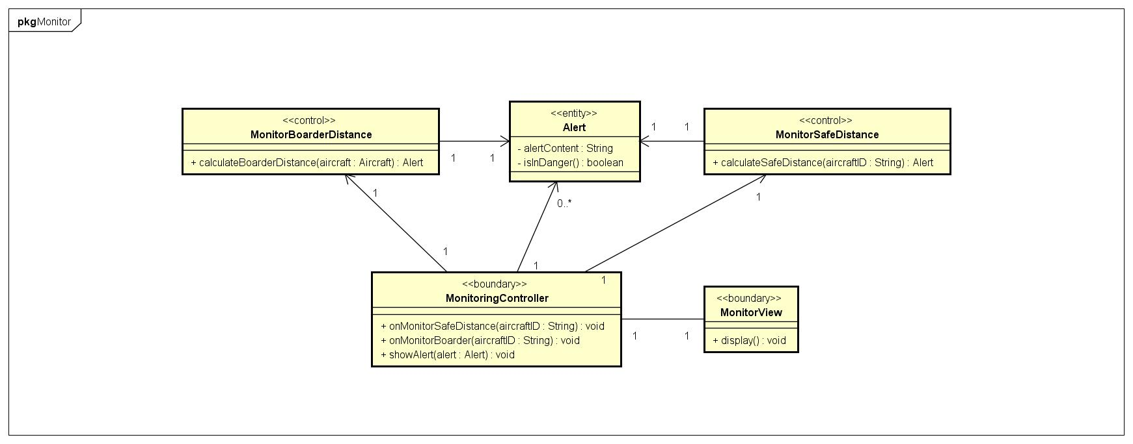

## 4.6 Radar System

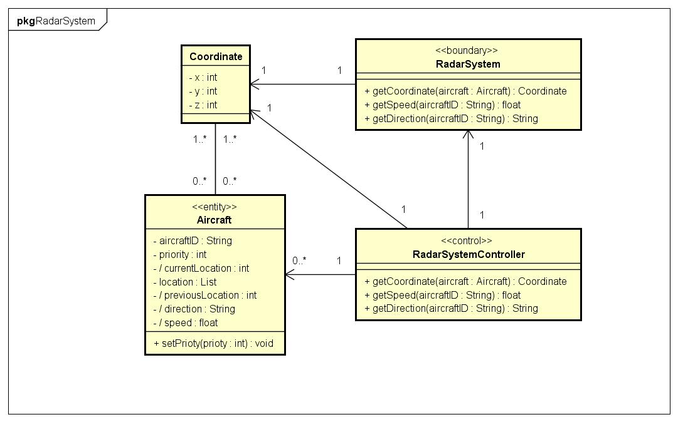

## 4.7 Schedule

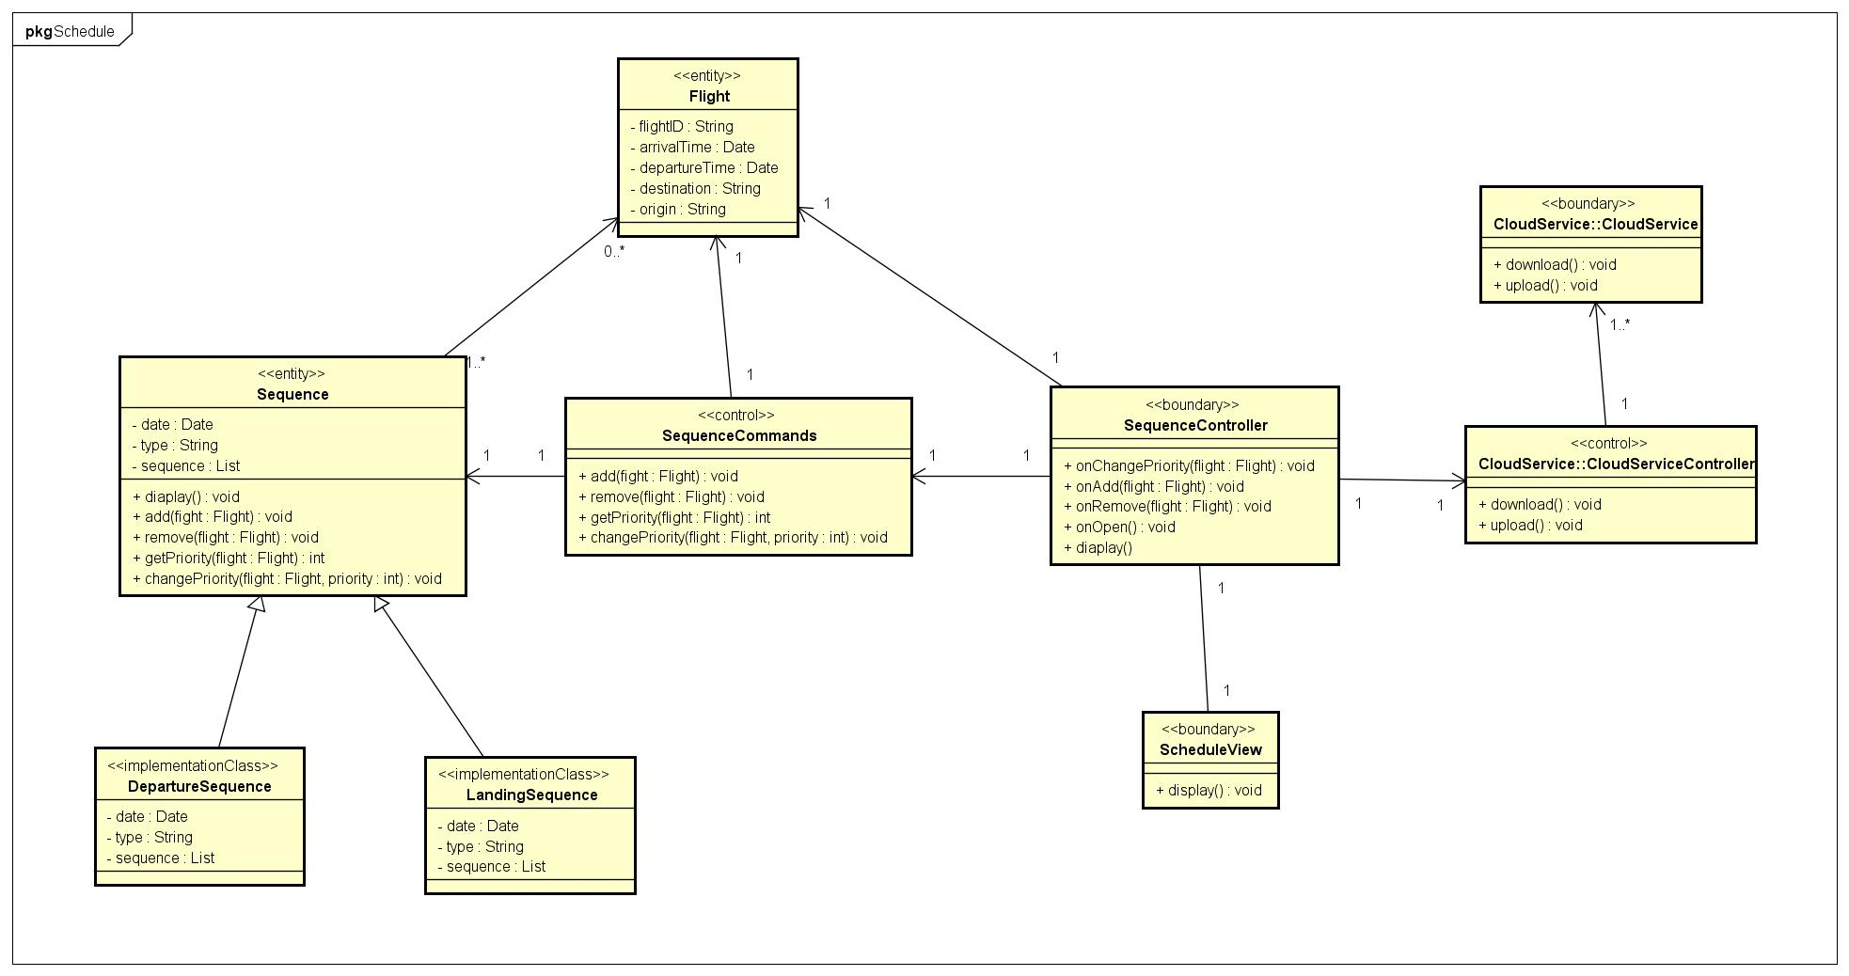

## 4.8 Tower Control

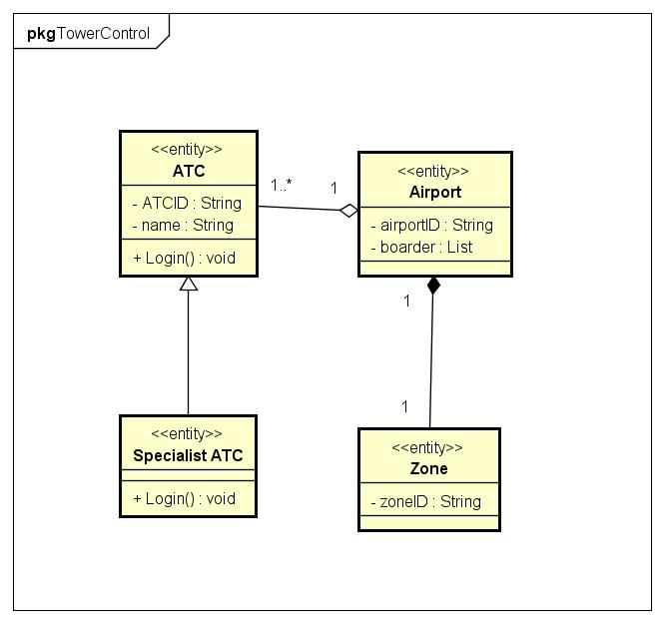

# Interaction Diagrams

## 5.1 Sequence Diagram

### 5.1.1 Broadcast Sequence Diagram

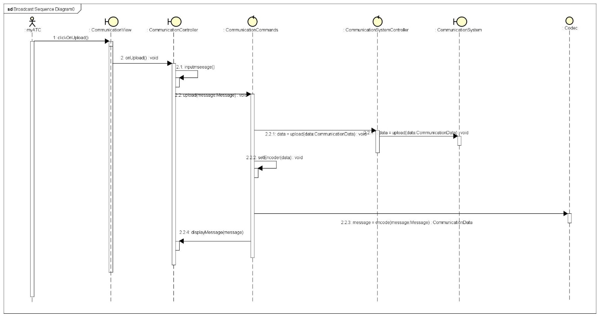

### 5.1.2 Monitor Safe Distance Diagram

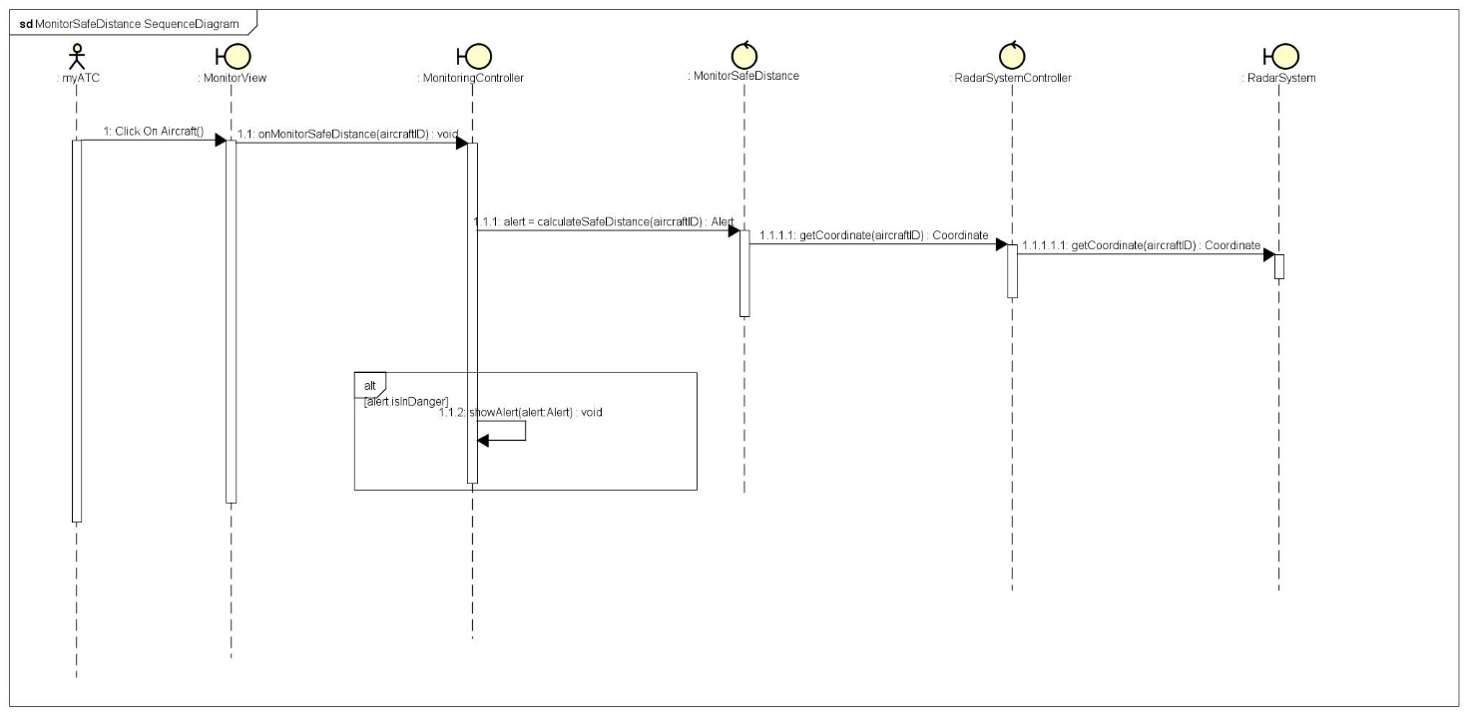

### 5.1.3 Remove Canceled Aircraft Sequence Diagram

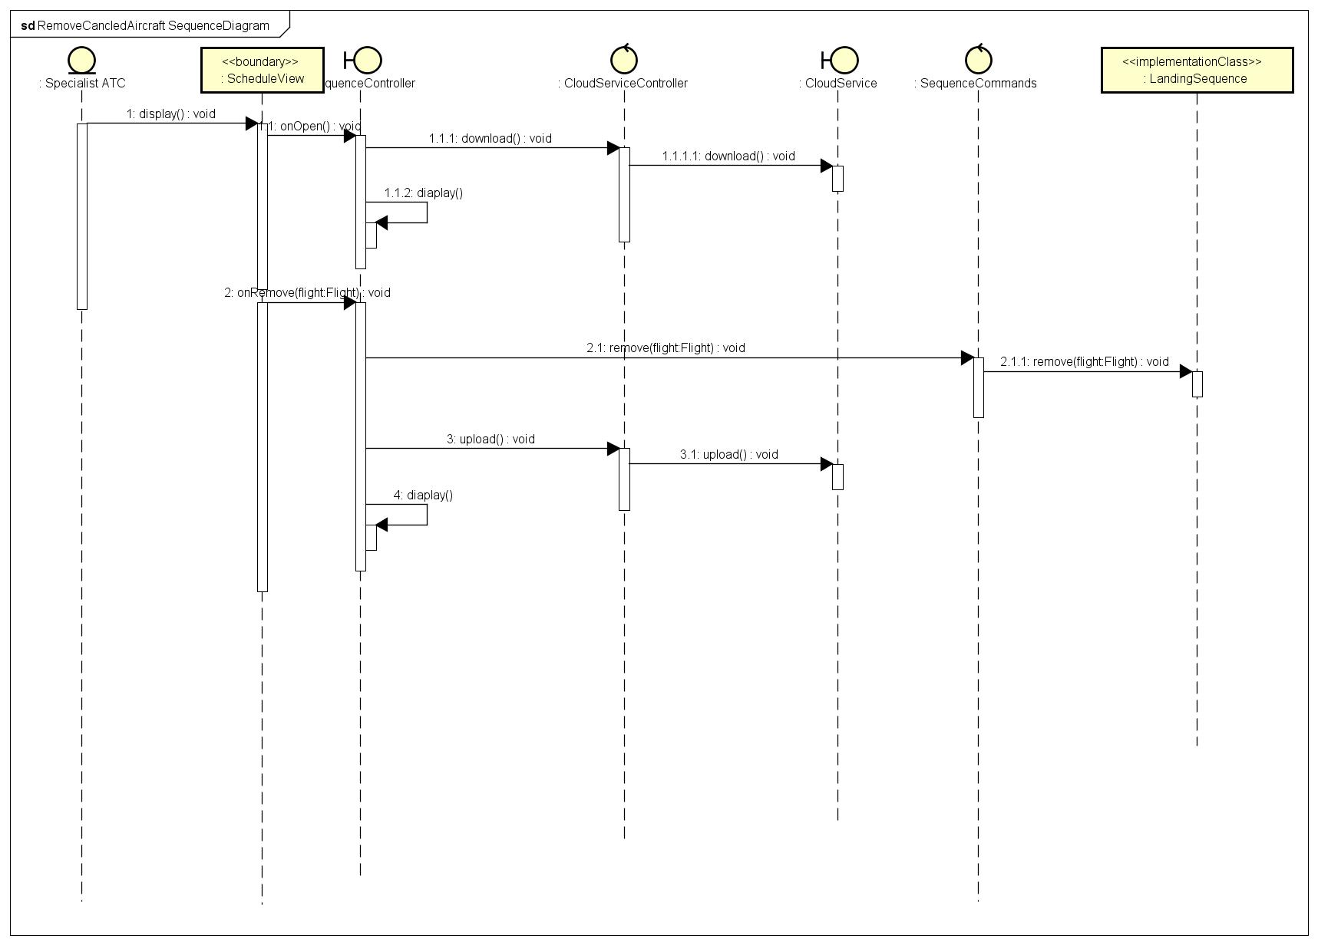

## 5.2 Communication Diagram

### 5.2.1 Change Priority of Landing Queue

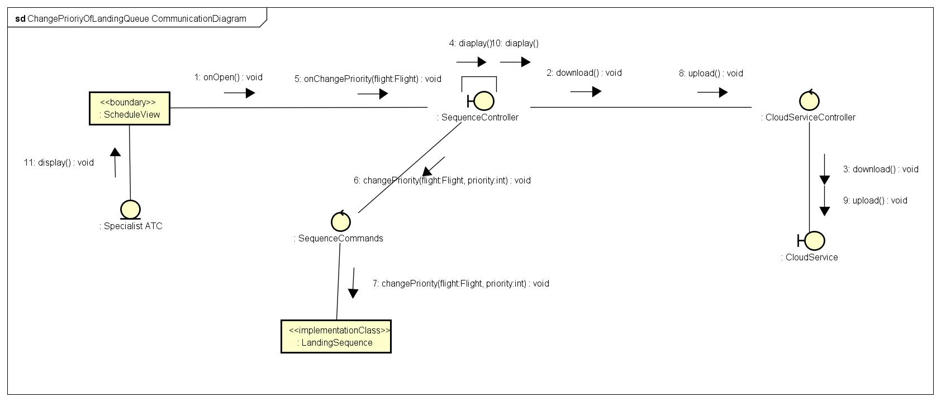

### 5.2.2 Monitor Boarder

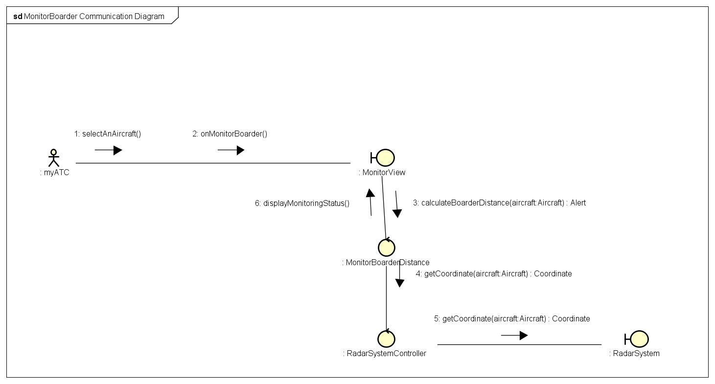

### 5.2.3 Send One-to-One Instructions

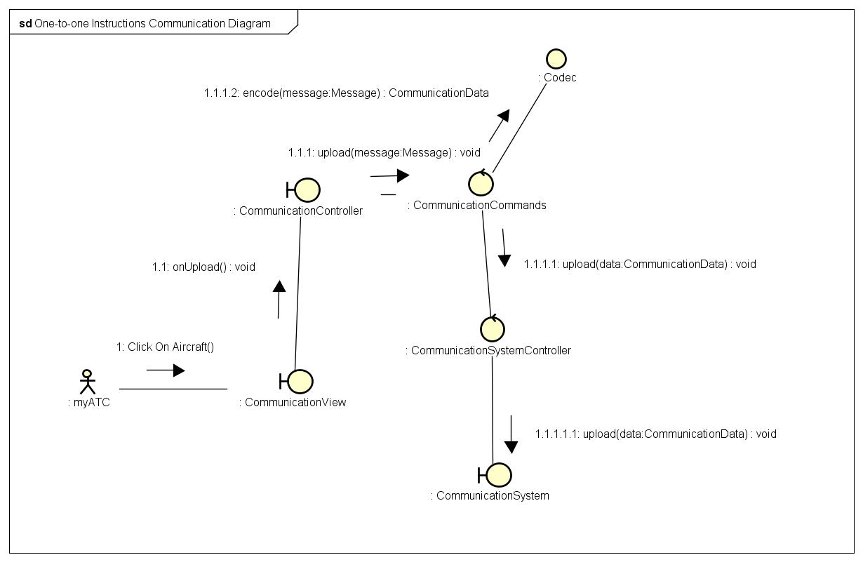

# State Machine Diagrams

## 6.1 Aircraft

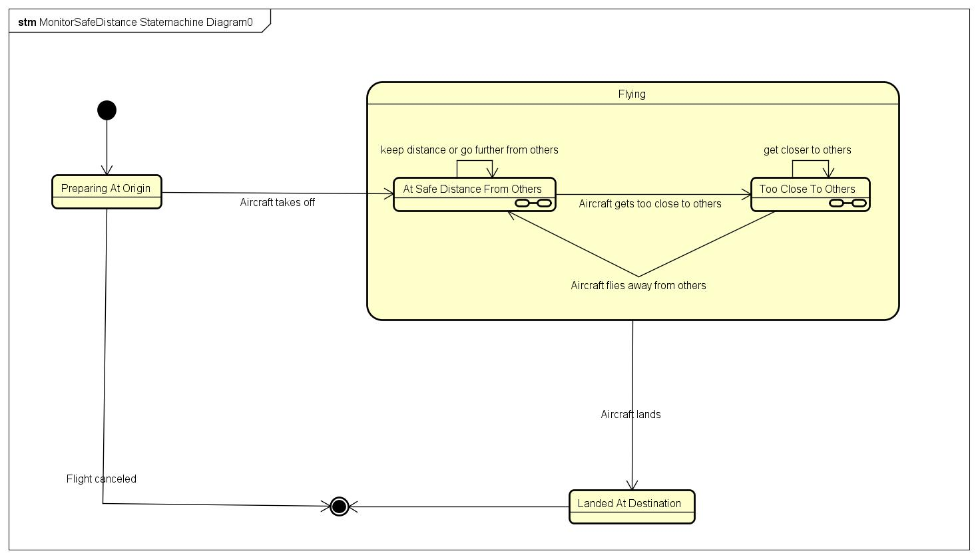

## 6.2 Flight

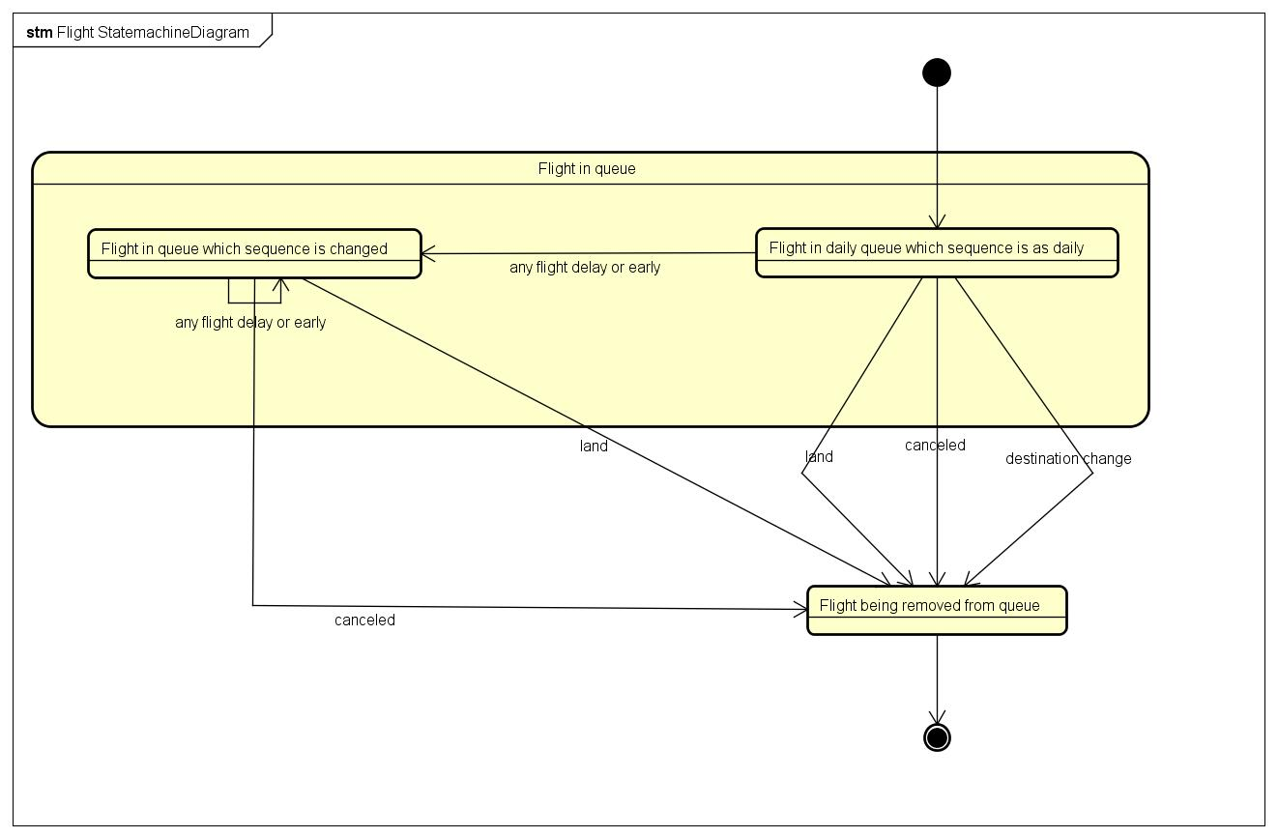

## 6.3 Message

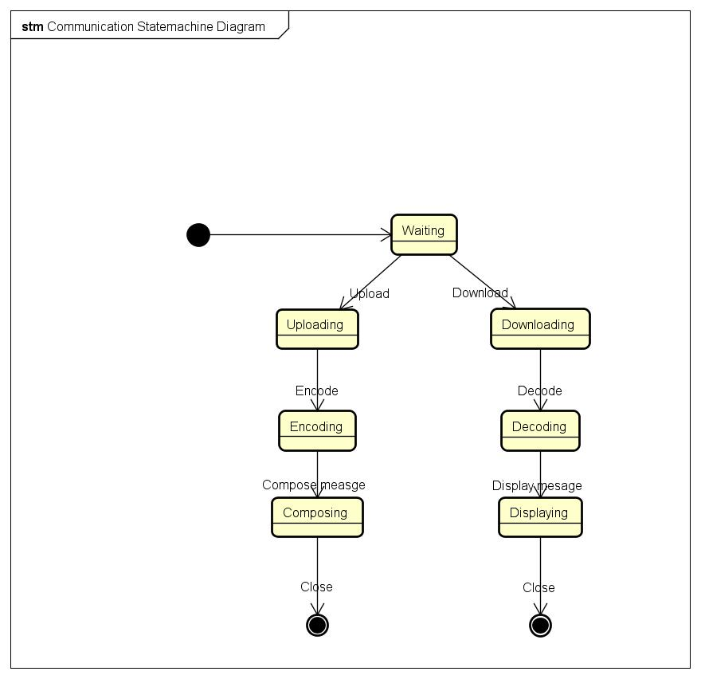

# Summary

This document provides a detailed design and deployment of the Air Traffic Control Software on PC. It followes the MVC pattern and separates the business logic from the GUI design. The system is devied into 3 parts according to its function: schedule, monitor and communicate. Each part has an MVC controller that responses to user’s commands.

# References

* Air Traffic Control. (n.d.). Retrieved October 31, 2018, from <https://en.wikipedia.org/wiki/Air_traffic_control>
* Air Traffic Controllor. (n.d.). Retrieved November 1, 2018, from <https://en.wikipedia.org/wiki/Air_traffic_control>lor
* How Air Traffic Control Works. (n.d.). How Stuff Works. Retrieved October 31, 2018, from https://science.howstuffworks.com/transport/flight/modern/air-traffic-control.htm